Excel Assignment – 6

1. What are the various elements of the Excel interface? Describe how

they're used.

Ans-

\*Ribbon: The main user interface for Excel is the Ribbon. It is made up of tabs that are separated into sets of connected commands. Depending on what is selected in Excel, the tabs and groups alter. The Ribbon can be used for many different things, including formatting cells, making charts, and working with formulas.

\*Quick Access Toolbar: Located above the Ribbon, this toolbar can be customised and offers quick access to frequently used commands. To meet your needs, you can add or remove commands from the toolbar.

\*Worksheet: The Worksheet is the main area where you enter data and perform calculations in Excel. It consists of a grid of cells that are organized into rows and columns. You can enter text, numbers, formulas, and functions into cells.

\*Column and Row Headers: To distinguish between columns and rows, look for the column and row headers at the top and left of the worksheet. Rows are denoted by numbers, whereas columns are denoted by letters. The headers can be used to navigate the Worksheet and to refer to specific cells in calculations.

\*Name Box: The Name Box is located to the left of the Formula Bar and displays the cell reference of the selected cell or range of cells. You can also use the Name Box to name cells and ranges.

\*Formula Bar: Below the Ribbon, the Formula Bar shows the contents of the currently chosen cell or the formula being typed. Formulas and functions can be entered and edited using the Formula Bar.

\*Status Bar: The Status Bar is located at the bottom of the Excel window and provides information about the current status of Excel, such as the mode of operation and the current cell mode. It also displays information about the selected cells, such as the sum, average, and count of the selected cells.

2. Write down the various applications of Excel in the industry.

Ans-

Excel is a powerful tool with a wide range of applications in various industries. Some of the common applications of Excel in the industry are:

\*Financial Analysis

\*Data Management

\*Project Management

\*Inventory Management

\*Human Resources

\*Sales and Marketing

\*Education

3. On the ribbon, make a new tab. Add some different groups, insert

commands in the groups and name them according to their commands

added. Copy and paste the screenshot of the steps you followed.

Ans-

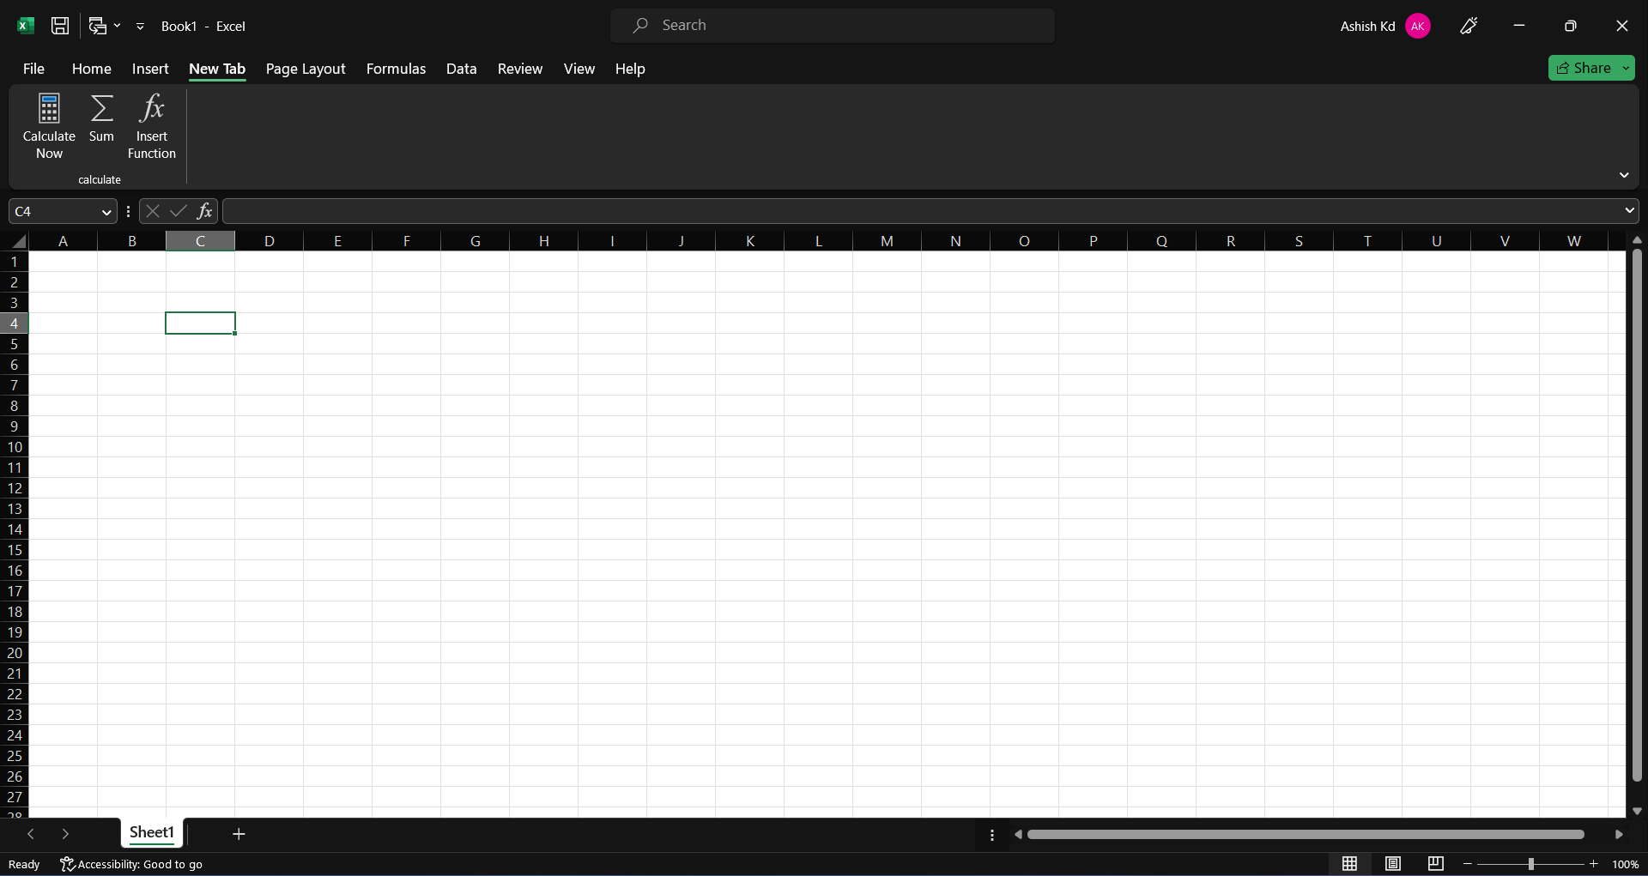

\*Right-click on any existing tab on the ribbon and select "Customize the Ribbon".

\*In the Excel Options dialog box, click on the "New Tab" button at the bottom.

\*Rename the new tab by selecting it and clicking on the "Rename" button.

\*Click on the "New Group" button to create a new group within the tab.

\*Rename the new group by selecting it and clicking on the "Rename" button.

\*Select a command from the list on the left side of the dialog box and click on the "Add >>" button to add it to the new group.

\*Click "OK" to save your changes and close the Excel Options dialog box.

4. Make a list of different shortcut keys that are only connected to

formatting with their functions.

Ans-

Here are some commonly used formatting shortcut keys along with their functions:

Ctrl+B: Bold

Ctrl+I: Italic

Ctrl+U: Underline

Ctrl+E: Center align

Ctrl+L: Left align

Ctrl+R: Right align

Ctrl+J: Justify align

Ctrl+D: Font dialog box

Ctrl+Shift+> or Ctrl+Shift+.: Increase font size

Ctrl+Shift+< or Ctrl+Shift+,: Decrease font size

Ctrl+Shift+A: All caps

Ctrl+Shift+K: Small caps

Ctrl+Shift+L: Apply list style

Ctrl+Shift+N: Apply normal style

Ctrl+Shift+M: Apply heading 1 style

Ctrl+Shift+T: Apply hanging indent

Ctrl+Shift+Space: Insert a non-breaking space

Ctrl+1: Single line spacing

Ctrl+2: Double line spacing

Ctrl+5: 1.5 line spacing

5. What distinguishes Excel from other analytical tools?

Ans-

Excel is a popular analytical tool that has become a standard for data analysis, reporting, and financial modeling in many industries. What sets Excel apart from other analytical tools is its user-friendly interface, versatility, and powerful analytical capabilities. Excel offers a wide range of formulas, functions, and features that make it easy for users to perform complex calculations and analysis. It also has a rich library of charting and visualization tools that allow users to create dynamic and interactive charts and graphs to better understand their data. Moreover, Excel is a versatile tool that can be used for a variety of tasks, including project management, budgeting, and forecasting, making it a go-to tool for professionals across different industries. Lastly, Excel supports macros and automation, which enable users to automate repetitive tasks and streamline their workflows, saving them time and effort.

6. Create a table and add a custom header and footer to your table.

Ans-

\*Open a new or existing document in Microsoft Word.

\*Place the cursor where you want to insert the table.

\*Click on the "Insert" tab in the top menu.

\*Click on the "Table" icon and select the number of rows and columns you want in the table.

\*Once the table is created, you can customize it by selecting the table and then clicking on the "Table Design" tab in the top menu.

\*In the "Table Design" tab, you can select a table style, adjust the border and shading, and format the font and alignment.

\*To add a custom header, click on the "Insert" tab and then click on "Header" from the top menu.

\*Choose a pre-designed header or select "Edit Header" to create your own custom header. Add your text and graphics as desired.

\*To add a custom footer, click on the "Insert" tab and then click on "Footer" from the top menu.

\*Choose a pre-designed footer or select "Edit Footer" to create your own custom footer. Add your text and graphics as desired.

\*Preview your document to make sure the header and footer look as expected.